APPENDIX E: APPLICATION SURVEYS FOR THE INVESTIGATION INTO VOICE-CONTROLLED WEB BROWSING FOR ELDERLY USERS

Kirti Nathoo

School of Electrical & Information Engineering, University of the Witwatersrand, Private Bag 3, 2050, Johannesburg, South Africa

# Introduction

A voice-controlled web application has been designed to increase the usability of web browsing for the elderly. Numerical and link name referencing techniques have been incorporated into the application to determine the most efficient method for speech recognition. Additional visual and verbal feedback methods have been incorporated to assist elderly users. The application has been decomposed into three iterations which have each been implemented and tested. Individual surveys have been designed for each iteration. Screenshots of the surveys have been included. These surveys instruct and assist developers in testing users and collecting data.

# APPLICATION SURVEYS

Specific surveys were designed for each iteration in order to obtain an accurate assessment of the iteration and to use the data collected for future iterations. The first page of each survey requests general information about the user as shown in figure 1. General information such as: age, gender, race, medical conditions, etc. The level of computer literacy of the user is noted and whether the user is accented. For each of the iterations, the user is guided through a series of use cases defined for each section within the application. The number of user and application errors are recorded. User errors are mistakes made by the user whilst using the application. Application errors are caused by the speech recognition component and occur when commands are misread, not recognised or not accepted at all. In addition to the recording of errors, users have been questioned to determine which referencing techniques they prefer using and which techniques they felt performed the best.

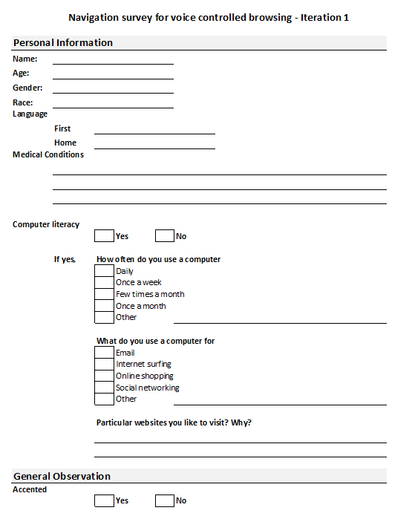

Figure 1: General user information

For iteration one users were questioned to ascertain which of the feedback techniques provide the most valuable form of feedback and if users prefer a combination of referencing and feedback techniques. The survey designed for iteration one is shown in figures 2-3.

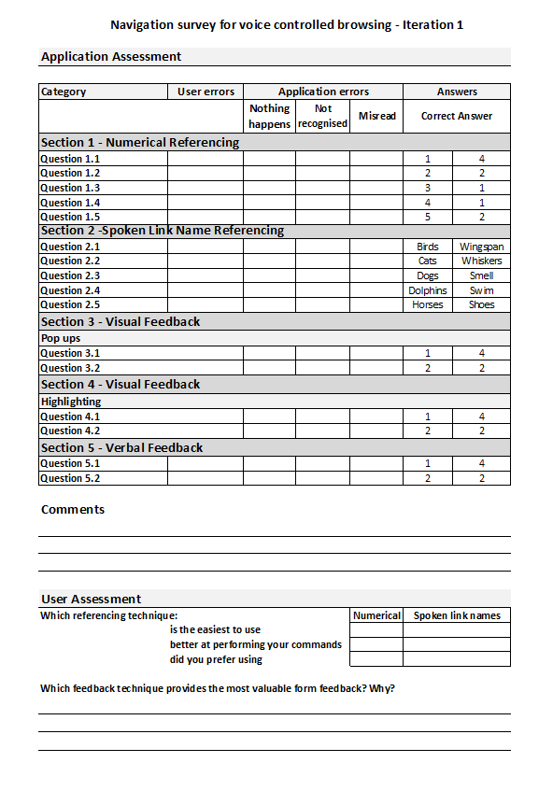

Figure 2: Page one of iteration one survey

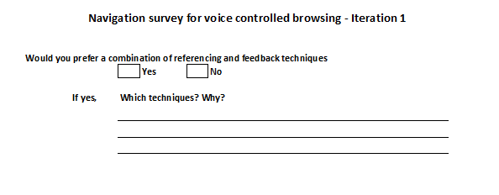

Figure 3: Page two of iteration one survey

Users were asked similar questions for iteration two. However, in iteration two users were additionally questioned on which of the two referencing techniques would be more confusing on more complex web pages with a greater number of links. Users were asked which technique was preferred for link name referencing: saying a specific word, part of a sentence or the complete sentence. The complete survey designed for iteration two is illustrated in figures 4-5.

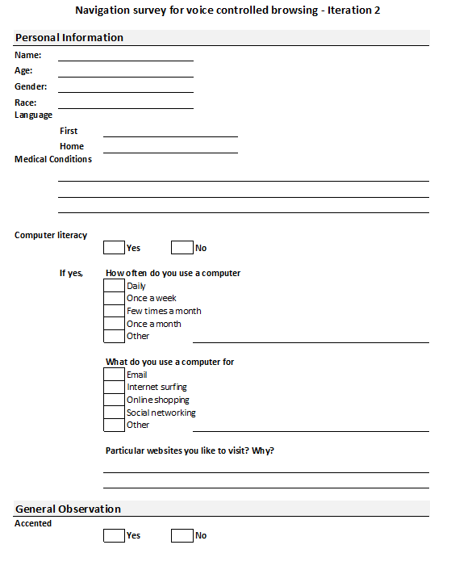

Figure 4: General user information page for iteration two survey

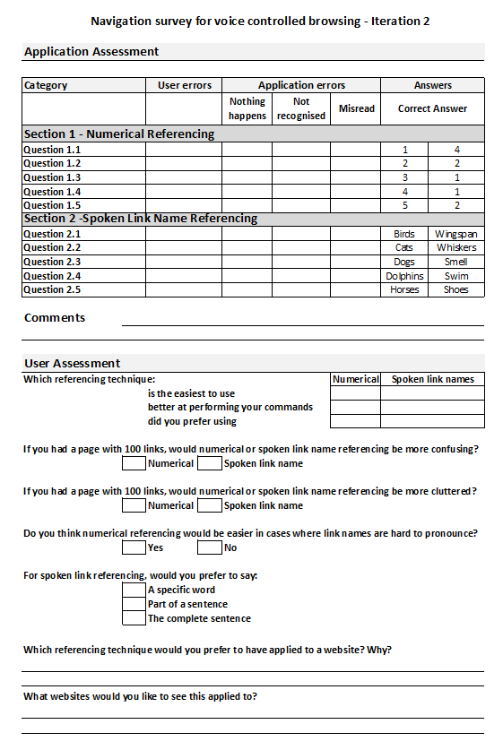

Figure 5: Use cases and questions for iteration two survey

Users in iteration three were questioned about the finer details of the implemented techniques. Such as users were asked if a different numbering style for numerical referencing would be more beneficial or if annotating a web page in terms of colours would improve the usability of the web page. In addition, users were queried to ascertain is certain application requirements were acceptable such as having to press a button to activate the speech recognition or if user confirmation was an unnecessary functionality. The survey designed for iteration three is illustrated in figures 6-10. Users were tested and the completed surveys are included.

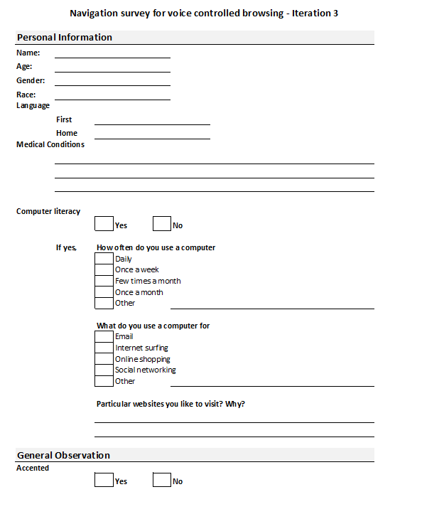

Figure 6: General user information page for iteration three survey

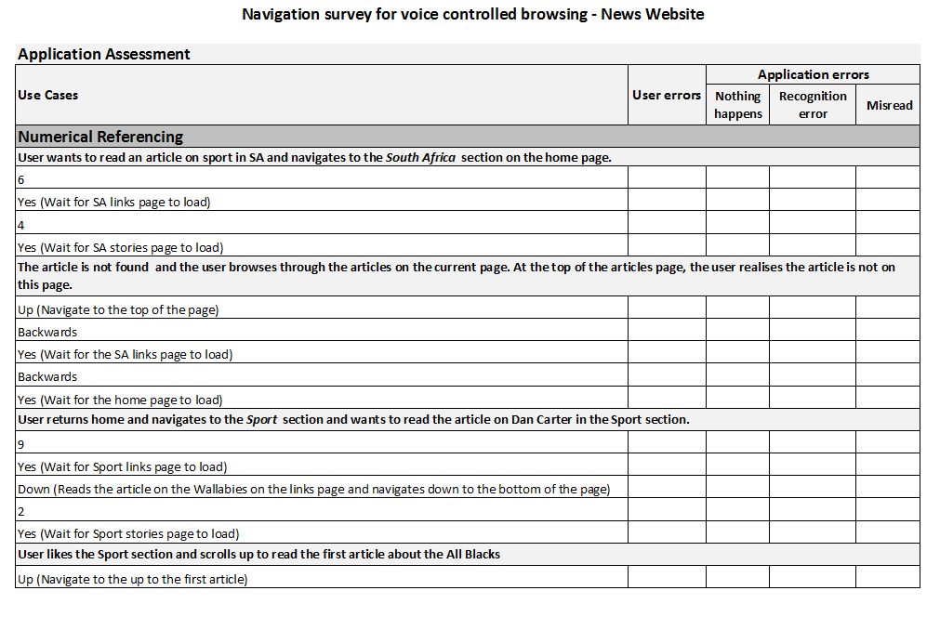

Figure 7: Use cases for testing the numerical referencing technique in iteration three

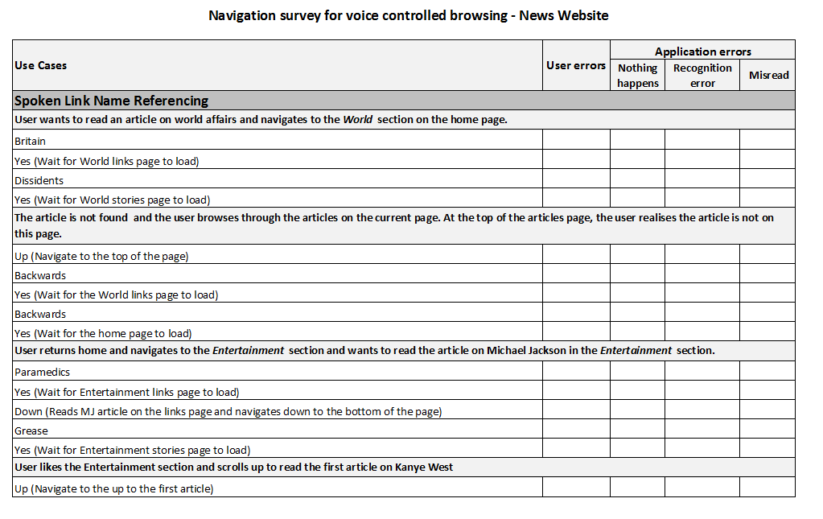

Figure 8: Use case for testing the link name referencing technique in iteration three

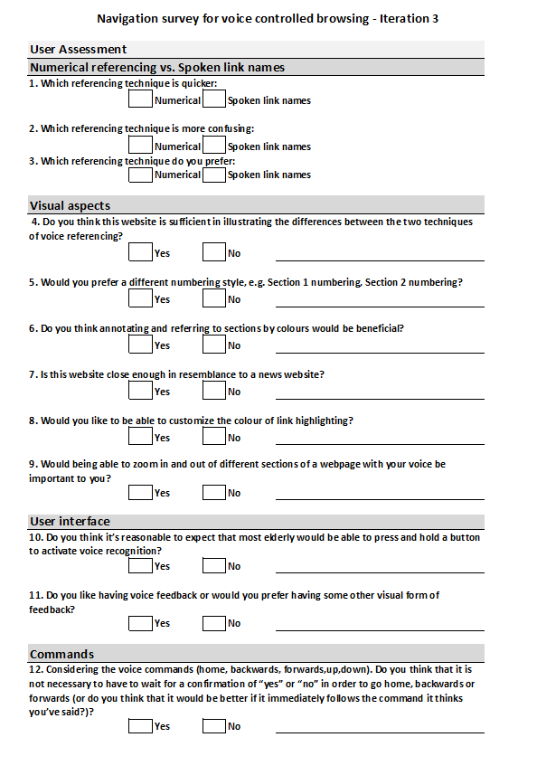

Figure 9: First page of questions for users in iteration three’s survey

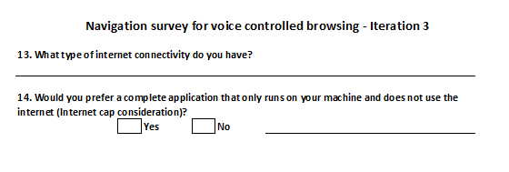

Figure 10: Final page of questions for users for in iteration three’s survey

# CONCLUSION

Surveys are an excellent method to assess the performance of an application and to provide developers with adequate user feedback. Iterations assists developers in decomposing the application into smaller segments which makes testing of specific requirements significantly easier. The results recorded in the completed surveys are used to guide the development of following iterations and are analysed to complete the investigation into voice-controlled web browsing for the elderly.